EXPT NO: 5 | IMPLEMENTATION OF A RECURRENT NEURAL NETWORK (RNN) FOR TEXT GENERATION
DATE: 24-08-2026

PRE-LAB QUESTIONS (PROVIDE BRIEF ANSWERS TO THE FOLLOWING QUESTIONS)
1. Explain the purpose of a Recurrent Neural Network (RNN) in processing sequential data.
Answer:
The purpose of an RNN is to process sequential data by considering the current input along with information from previous inputs. It uses a hidden state to remember past information, making it useful for data such as text, speech, and time-series data.
2. Why is an RNN considered an appropriate model for text generation tasks?
Answer:
An RNN is suitable for text generation because text is sequential, where the next word or character depends on the previous ones. The RNN remembers previous words through its hidden state and uses this information to predict the next word or character.
3. Describe the concept of sequence modeling in Natural Language Processing.
Answer:
Sequence modeling is the process of understanding and predicting data where the order of elements is important. In NLP, it is used to analyze sequences of words or characters and understand their context. For example, an RNN can use previous words to predict the next word in a sentence.
4. Explain the importance of tokenization during text preprocessing for RNN-based text generation.
Answer:
Tokenization is the process of breaking text into smaller units called tokens, such as words or characters. It converts a sentence into manageable parts so that the RNN can process the text efficiently. For example, "I love AI" can be tokenized as ["I", "love", "AI"].
5. Explain the significance of converting text into numerical representations before training an RNN.
Answer:
RNNs cannot directly process text because neural networks work with numerical values. Therefore, words or characters are converted into numbers, such as token IDs or embeddings. These numerical representations allow the RNN to learn patterns and relationships in the text during training.

AIM
To implement a Recurrent Neural Network (RNN) for text generation and evaluate its ability to generate meaningful text by predicting the next word in a sequence.

SOFTWARE REQUIREMENTS
- Python
- TensorFlow or keras or PyTorch
- Google Colab
- GitHub
- Numpy
- Matplotlib

OBJECTIVES
Students will be able to:
- Understand the architecture and working of Recurrent Neural Networks (RNNs).
- Perform text preprocessing techniques for sequence modeling.
- Generate input sequences suitable for training an RNN model.
- Build and train an RNN model for text generation.
- Generate text by predicting the next word in a sequence.
- Evaluate the performance of the trained RNN using generated text.
- Analyze the effectiveness of RNNs in learning sequential patterns from textual data.
PROCEDURE
PART A: DATASET PREPARATION
Perform the following tasks:
- Load the Tiny Shakespeare dataset from Hugging Face.
- Explore the dataset and examine the text samples.
- Convert the text into lowercase (if required).
- Tokenize the text into individual words.
- Build a vocabulary and assign a unique integer index to each word.
- Generate input sequences for next-word prediction.
- Apply sequence padding to obtain inputs of equal length.
- Split the prepared sequences into training and validation datasets.
CODE:

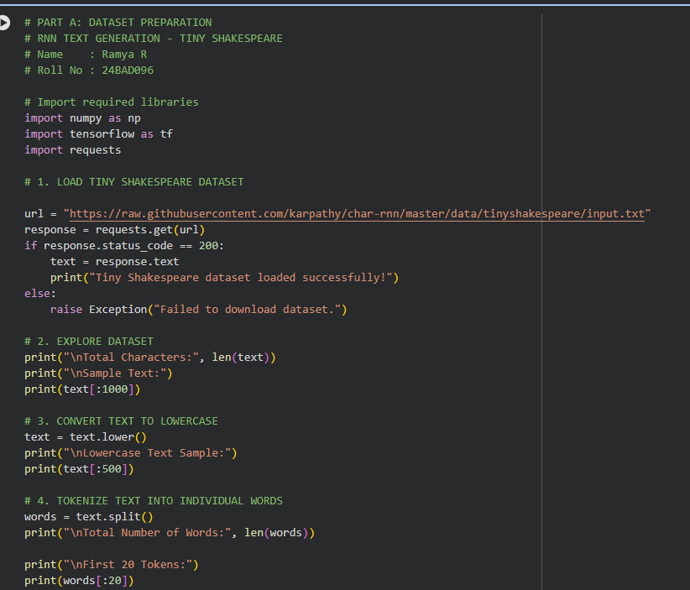
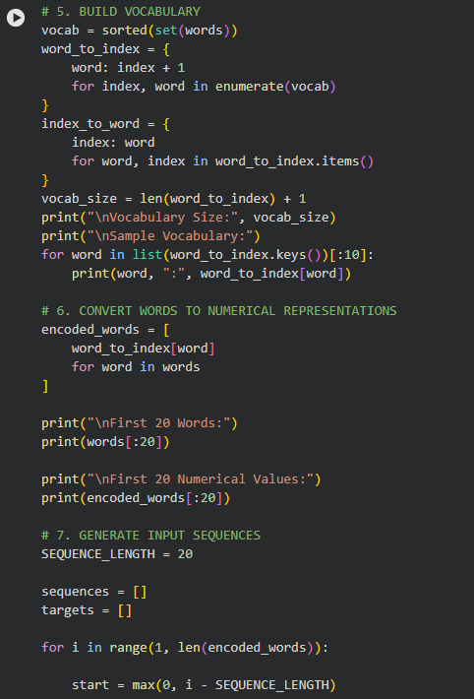
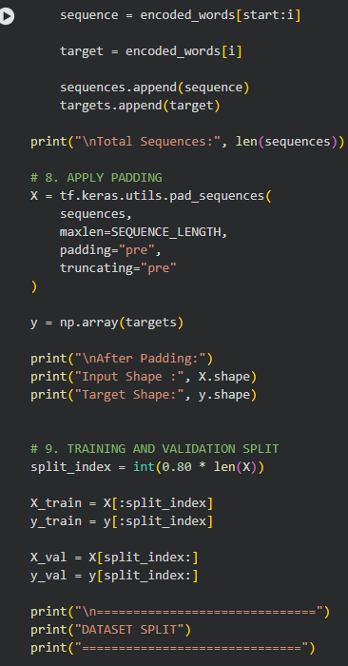
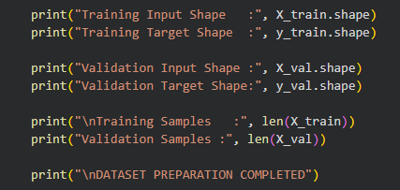
OUTPUT:
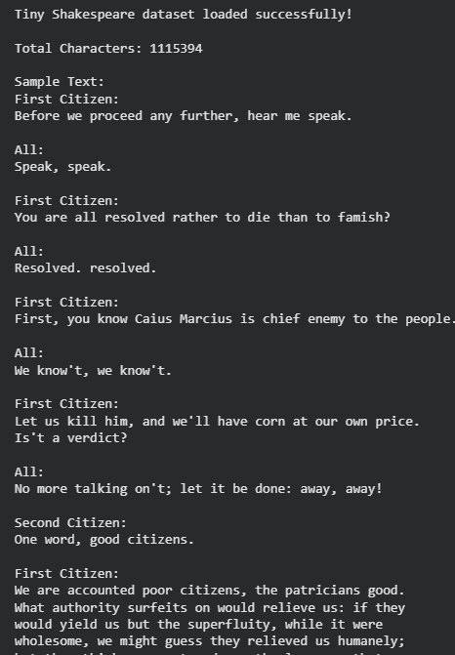
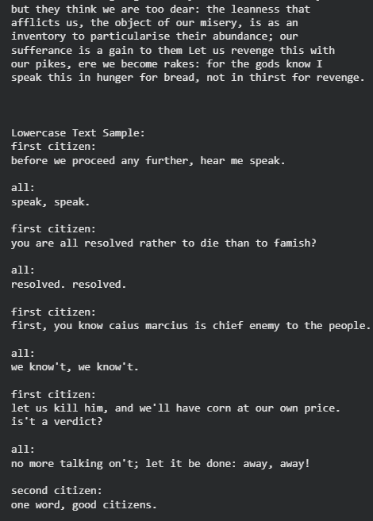
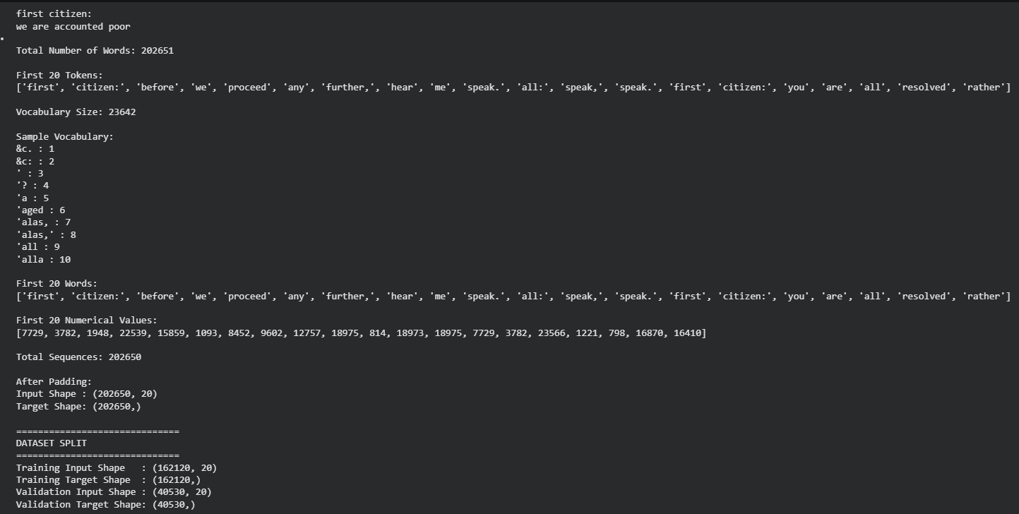
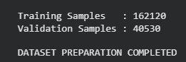
PART B: IMPLEMENTING THE RNN MODEL
Perform the following tasks:
- Create an Embedding layer to convert words into dense vector representations.
- Add a Simple RNN layer to learn sequential dependencies in the text.
- Add a Dense output layer with Softmax activation for next-word prediction.
- Compile the model using an appropriate optimizer and loss function.
- Display the model architecture and summary.
CODE:
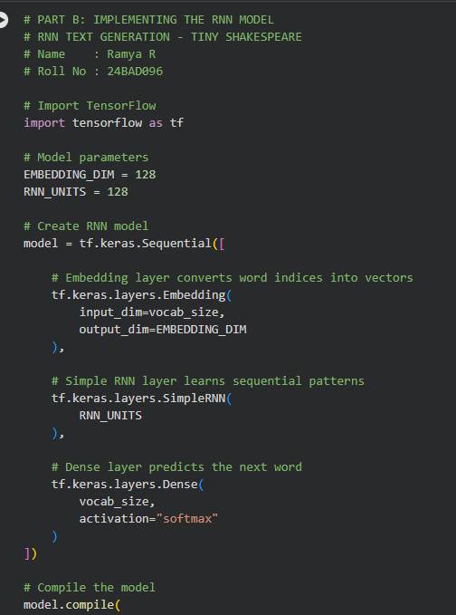
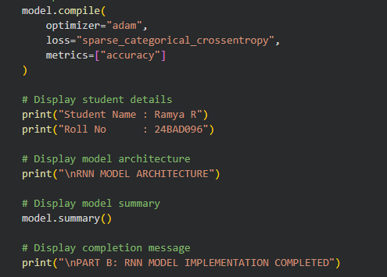
OUTPUT:

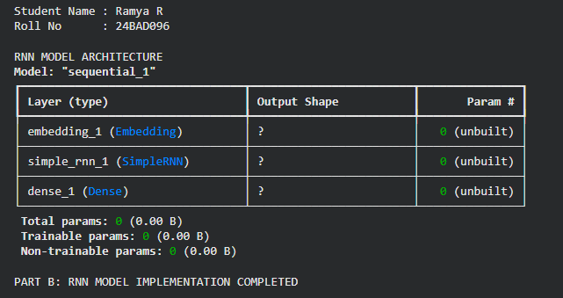

PART C: COMPARISON OF OPTIMIZATION ALGORITHMS
Perform the following tasks:
- Train the RNN model using the prepared training dataset.
- Validate the model using the validation dataset.
- Record:
  - Training accuracy
  - Validation accuracy
  - Training loss
  - Validation loss
- Visualize:
  - Accuracy vs. Epoch
  - Loss vs. Epoch

CODE:
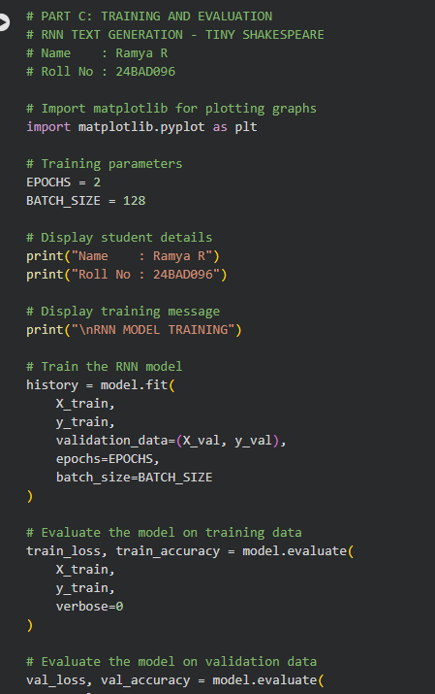
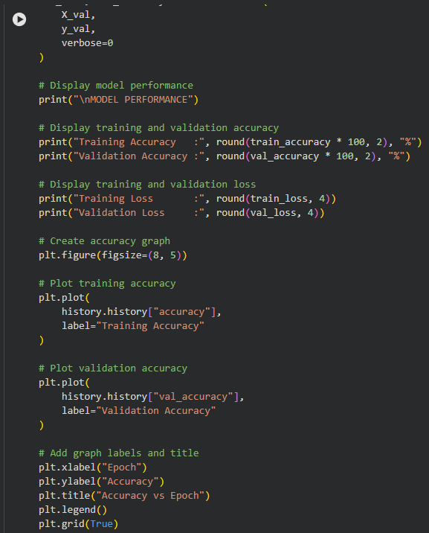
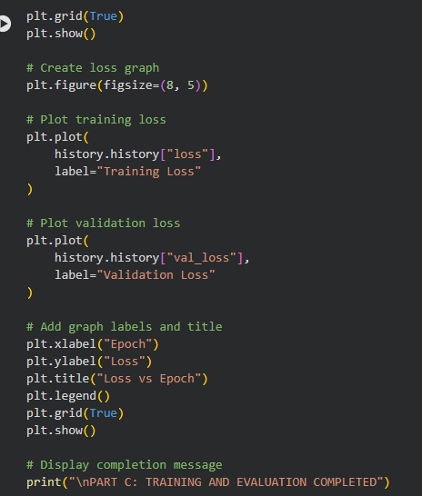
OUTPUT:
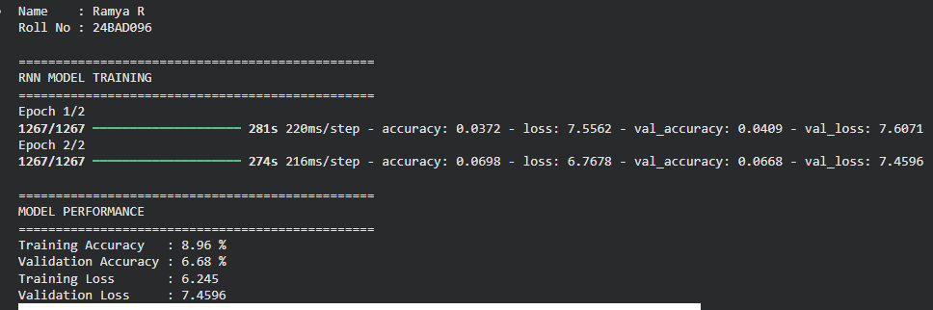
OUTPUT:
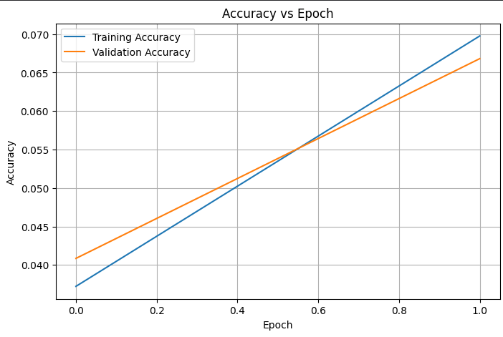
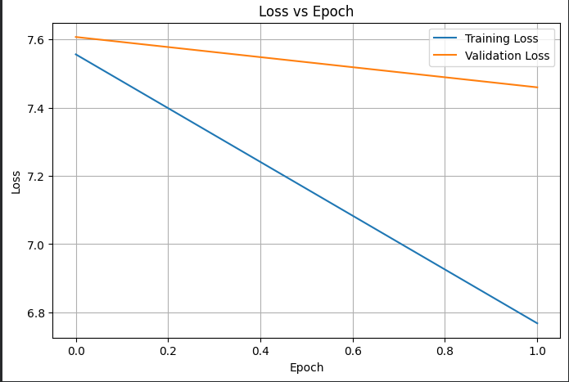
PART D: DEEP LEARNING EXPERIMENT MANAGEMENT
Perform the following tasks:
- Provide a seed word or sentence as input to the trained model.
- Generate text by repeatedly predicting the next word in the sequence.
- Produce multiple text samples using different seed inputs.
- Compare the generated text for coherence and contextual relevance.
- Document the observations and upload the notebook to GitHub.
CODE:
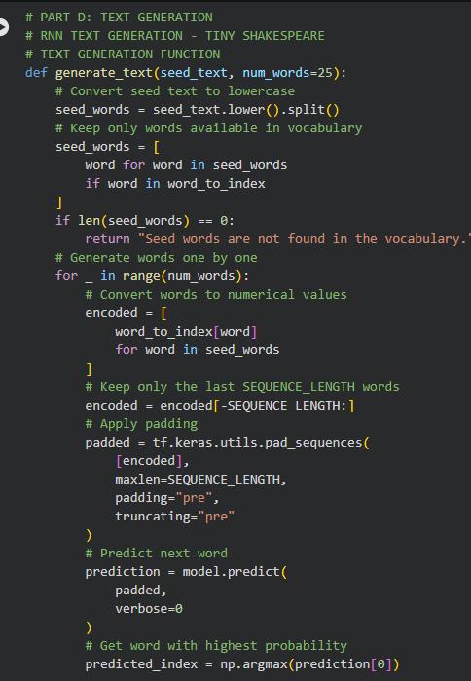
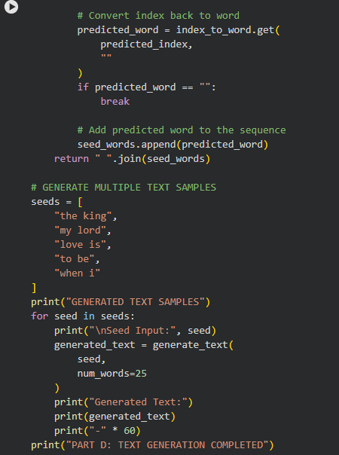
OUTPUT:
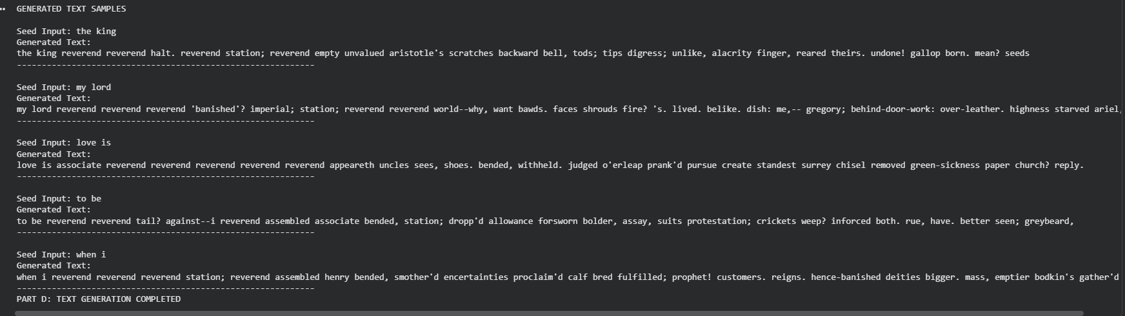

EXPECTED OUTCOME
Students will understand how an RNN learns sequential information and generates meaningful text based on previously learned patterns. Students will learn to preprocess textual data and train a Recurrent Neural Network (RNN) for text generation. They will evaluate the model's performance using training metrics and generate text through next-word prediction.

POST-LAB QUESTIONS (PROVIDE BRIEF ANSWERS TO THE FOLLOWING QUESTIONS)
1. Describe the role of the hidden state in an RNN during sequence processing.
Answer:
The hidden state stores information from previous time steps. It acts as the RNN’s memory, helping the model understand the context of the current input and make better predictions.
2. Discuss the effect of training an RNN model for an insufficient number of epochs.
Answer:
Training for too few epochs may cause underfitting. The model does not learn enough patterns from the training data, resulting in poor text generation and low accuracy.
3. Explain the purpose of padding when preparing text sequences for RNN training.
Answer:
Padding is used to make sequences of equal length. Shorter sequences are filled with special padding values so that all sequences can be processed together in batches.
4. Discuss one limitation of a Simple RNN when processing long text sequences.
Answer:
A Simple RNN may have difficulty remembering information from very long sequences due to the vanishing gradient problem. As a result, it may lose important earlier context.
5. Discuss the effect of sequence length on the performance of the text generation model.
Answer:
A longer sequence provides more context, which can improve text generation. However, very long sequences require more memory and computation and may make training slower.

ASSESSMENT
Description | Max Marks | Marks Awarded
Pre Lab Exercise | 5
In Lab Exercise | 10
Post Lab Exercise | 5
Viva | 10
Total | 30
Faculty Signature

